****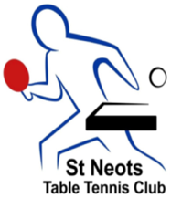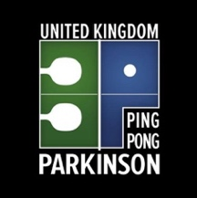

|  |  |
| --- | --- |
|  |  |

**Ping Pong Parkinson**®

**UK National Table Tennis Championships**

**SATURDAY 21st August 2021**

**Venue**

**St Neots Table Tennis Club**

**New Street**

**St Neots**

**CAMBS**

**PE191RU**

**Referee: Dave Cochrane NR**

**Deputy Referee: Dan Bullen TR**

**Organiser: Dan Bullen (TO2) & Dave Cochrane (TO4)**

**Organising committee: Dan Bullen TO2, Dave Cochrane (TO4),**

**Paul Nicholls and Gary Lee**

**Entries Closing Date**

**Monday 9th August 2021**

**Date of Draw: Monday 16th August 2021**

DIRECTIONS TO St Neots Table Tennis

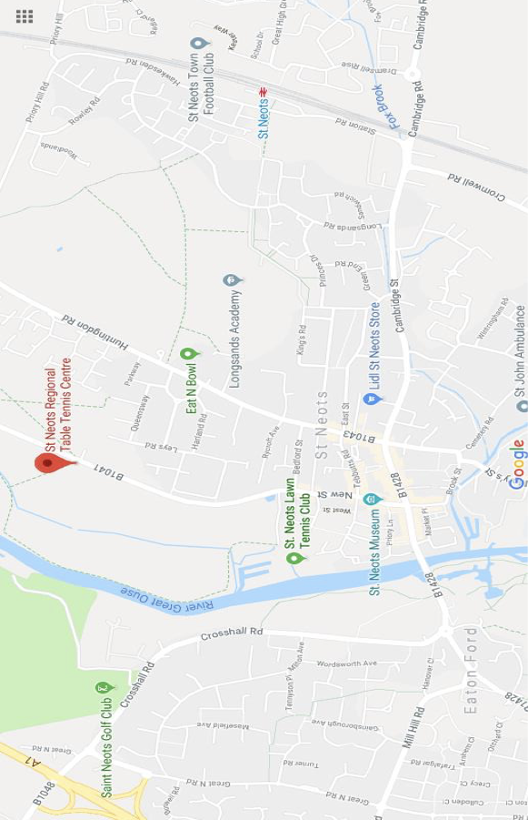New Street, St. Neots PE19 1RU

Next Door to the Rugby Club

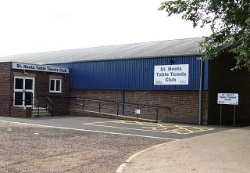

**EVENT REGULATIONS**

There will be two events during the day : **For this competition, ALL entrants must be members of Table Tennis England and eligible to play for UK**.

[**https://tabletennisengland.co.uk/membership/register-or-renew/**](https://tabletennisengland.co.uk/membership/register-or-renew/)

**(MORNING EVENT)**

**1. Class Singles**

There will be three class levels. Players may only play in one class:

**Class One:** **High Range - Limited muscle movement and low mobility.**

**Class Two:** **Medium Range – Reasonable muscle movement and mobility.**

**Class Three: Low Range – Good muscle movement and mobility**.

**(AFTERNOON EVENT)**

**2. Open Event**

**The Open event is an event based on standard of players.**

**Band A – This is for advanced level of players. ( TTE Grand Prix or Div 1 local league)**

**Band B – This is for Intermediate level of players. (Div 2 local league or below)**

**Band C – This is for Beginner level of players**. (Non League or tournament player)

**3. Merging of categories**

will be split into male and female categories. Organisers will merge classes and/or male & female categories if entries received are less than 4 players in same class or male / female categories) for open events.

**4. Alterations**

No alterations to the draw will be done unless it is to correct an error. If entrants drop out the groups will not be changed unless it causes serious imbalance to seeding i.e 2 on same half of draw.

**CLOSING DATE**

Entries should be received by **Monday 9th August 2021**. Any entries accepted after that date will be at the discretion of the referee/organiser.

Should the number of entries exceed the time we have available for the event, the organizer reserves the right to decline entries based on last in first out.

**AWARDS**

Awards will be presented to the winner, losing finalist and third place of each event. A third place play off will take places.

**ACCOMMODATION**

There are several hotels in the area. Websites such as [www.booking.com](http://www.booking.com) may help.

Travelodge and Premier Inn sometimes offer cheaper rooms if you book at least 21 days ahead.

**ENTRY FEES**

The entry fee is £20.00 per person and all entrants must be current members of TTE**.**

**PLEASE NOTE CARERS AND GENERAL SPECTATORS RECEIVE FREE ENTRY ON THE DAY.**

Entries will not be accepted without the correct payment and forms.

**Cheques should be payable to Mind2Muscle** direct payment is also accepted please see bank details on entry form. **(see entry form).**

**VIDEO AND PHOTOGRAPHY**

As per TTE’s policy, any person wishing to take photos at the event must register their details with staff on reception. This includes the use of a mobile telephone with photographic or video facility.

TTE or St. Neots TTC may take photographs/recording of you whilst at this event. These images

may appear in publicity material or websites. We therefore require all entrants to complete

the photography consent section of the entry form.

The organisers will only use images of athletes to promote sport recreation or competition

through publicity material, media, contacts or other appropriate means and will not include

personal email, postal addresses or telephone or fax numbers.

**copyright information**

any photographs should not be used without the express consent of the photographer who will own the copyright)

**Canteen**

St Neots TTC Club canteen will be open during the event serving Hot and cold food and drinks, menu will be sent out nearer the time.

**Equipment**

**Tables: 6 Butterfly Centrefold 25 Blue**

**Scoreboards: 6 Butterfly Duo scoreboard and 6 Butterfly Umpire’s Table**

**Nets: 6 Butterfly Europa Net and Post Set**

**Balls: Butterfly R40+ 3 Star White Balls (ITTF Approved)**

**PROVISIONAL PROGRAMME OF EVENTS (Subject to change)**

Saturday 21st August 2021 7:55am. Door open

8:30am Registration

9:00am Start Class 1-3 Singles

1 :15pm Lunch

2:15pm Open Event Band A-C

6:15pm Finish for day

All play will initially be on a group basis. Subject to the level of entries and time available it is hoped that, if required, both the winner and runner‑up of each group will proceed to a knockout stage.

**EVENT CONTACT**

**Please return completed entry complete with payment, to the organiser:**

**Dan Bullen**

**11a Kings Road**

**St Neots,**

**Cambridge.**

**PE191LD**

**Tel: 07920404411  
Email: bullentabletennis@outlook.com**

**Ping Pong Parkinson® UK National Table Tennis Championship 2021**

**ALL entrants must be members of TTE and eligible to play for UK.**

**Competition Date (SATURDAY 21st August 2021,**

**Entries Closing Date Monday 9th August 2021)**

Please **send forms** back to:

**Dan Bullen,11a Kings Road, St Neots, Cambridge. PE191LD Or**

**email: bullentabletennis@outlook.com**

**(Please complete one entry and one membership form for each player - entry depends on both)**

**PLAYER DETAILS**

|  |  |  |  |  |
| --- | --- | --- | --- | --- |
| Player Name |  | | Date of Birth | / / |
| Club **(if ANY)** |  | |  |  |
| Address |  | | Male or Female | M / F |
|  |  | | TTE Membership no |  |
|  |  | |  |  |
| Telephone | Home : | Mobile | | |
| Email  (BLOCK CAPITALS) |  | | | |

**ENTRY DETAILS**

|  |  |
| --- | --- |
| **Please state which class you will play in**: (refer to the classification guide) |  |

|  |  |  |  |
| --- | --- | --- | --- |
| Which events do you wish to enter (please tick): (see information pack for rules) | | | |
|  | tick |  |  |
| Open Singles |  | Please state your band (A, B or C) |  |
| Class Singles |  | Please state your class 1,2,3 |  |

Or bank transfer to Mind2Muscle sort code: 608301 Account number: 20431918

If paying by online banking, please put your name as reference and email Dan Bullen on **bullentabletennis@outlook.com**

**No Cash to be accepted unless agreed with the organiser before sending**

If you would like a receipt, please advise and we can email one.

**VIDEO/PHOTOGRAPHY CONSENT (PLEASE)** YES NO

Can we use your photograph in printed material and use to promote other events

**CONTACT DETAILS CONSENT (PLEASE)** YES NO

Can we keep your contact details to inform you of other Parkinson Competitions? _

**DECLARATION OF MEDICAL CONDITIONS**

I wish to compete in the Uk Ping Pong Parkinson National Table Tennis Competition. I understand that the organisers require me to state any known medical conditions other than Parkinson’s and their management.

known medical condition(s)/medication taken: (*print n/a if there are no other medical conditions)*

*please note that* ***(mind2muscle who specialise in all aspects of*** Parkinson’s ***will offer qualified level 4 first aid assistance)***

|  |
| --- |
|  |

**DECLARATION**

SIGNATURE OF PLAYER: ………………………………… DATE: ………………

SIGNATURE of PARENT/GUARDIAN IF UNDER AGE 18: …………………………….

**EMERGENCY CONTACT DETAILS**

Disclaimer – the organisers of the Ping Pong Parkinson Uk National Table Tennis Championships event accept no liability to entrants or spectators for any action taken by the entrant/s or spectators that may take that could cause serious injury to themselves or anyone else at the ping pong Ping Pong Parkinson UK National Championship event. Please note all entrants should check the liability offered by the club player membership insurance cover afforded to them when joining to ensure it meets their own individual requirements. by signing and returning this document it is understood the entrant understand and agrees to all terms of reference and conditions above.

Covid Rules

1. All participants and spectators must’ve MUST HAVE had at least one vaccine or a negative covert **(COVID)** test on the day of the event(e.g. if you have a **covid** covert test **the** **night** before you are not allowed to go anywhere  **you should self isolate** until you come to the event)

2. Masks Must be always worn unless you are playing on court or eating.

3. There will be a new ball provided per match.

4. Tables will be cleaned down after every match.

5. We will play best of 5 but will not be changing ends

These rules may change dependent on government guidelines - an update will be sent out by email nearer the time.

**Food menu**

A full menu will be sent out near to the time with full ranges of drinks, snacks, toasties, and paninis. However, St Neots Table Tennis Club would like you to order any hot food you would like for your lunches, so They know how many they are catering for.

**Hot Food options**

Jacket potato

With Cheese and Beans £2.80

Tuna sweetcorn £3.00

Spicy chicken £300

Fresh Soup with a roll £2.90

Tomato and basil

Moroccan chicken

Order slip please send back with entry form or by closing date

Jacket potato with cheese and beans Jacket potato with tuna sweetcorn

Jacket potato with spicy chicken Tomato and basil soup Moroccan chicken Soup